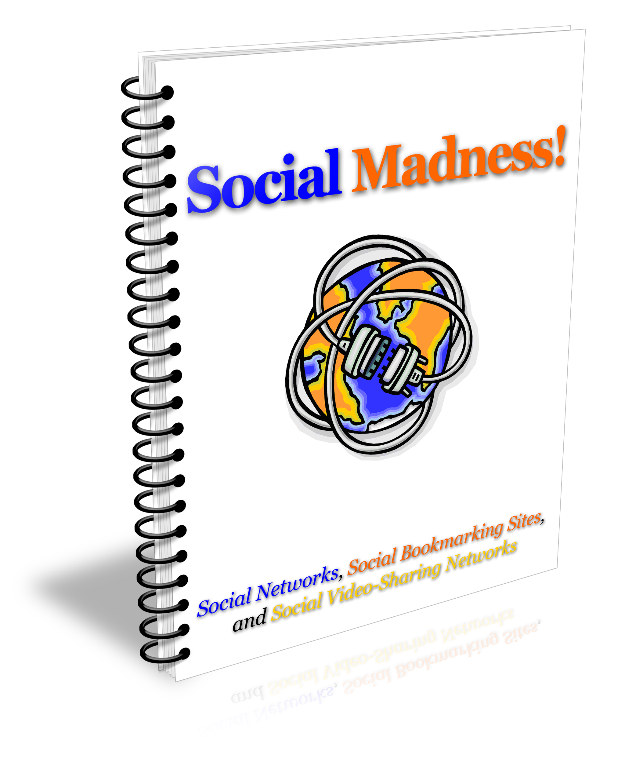

Social Madness!
Rights Statement

Full, unrestrictive rights come with this package, which includes:

- The eBook
- The eBook Cover Graphics
[YES] Can be sold.
[YES] Can be packaged.
[YES] Can be offered as a bonus.
[YES] Can be edited or modified and your name put on it.
[YES] Can be used as web content.
[YES] Can be used in blogs.
[YES] Can be used in autoresponder messages.
[YES] Can be given away.
[YES] Can be added to paid membership sites.
[YES] Can be offered through auction sites.
[YES] Can sell Resale Rights
[YES] Can sell Master Resale Rights
[YES] Can sell Private Label Rights

